Announcement on the Sale of Unclaimed Material and Technical Resources
RN ANGOCHE PTE. LTD.
(Branch of RN ANGOCHE PTE. LTD. in Maputo, Republic of Mozambique)
[document submission period: from 08 June 2026 to 07 July 2026, 17:00 (Moscow time) / 16:00 (Republic of Mozambique time)]
Company name: RN ANGOCHE PTE. LTD.
Lot item: | 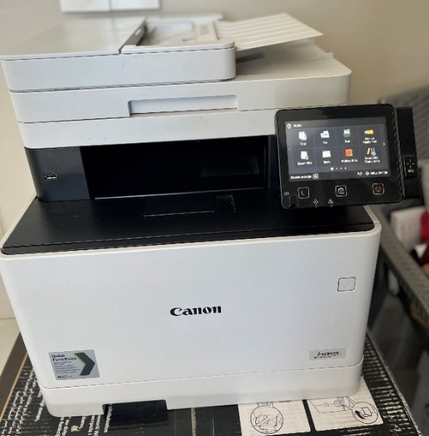  Canon i-SENSYS MF744Cdw multifunction device
Technical specifications  and condition  of the item for sale: | Canon i-SENSYS MF744Cdw multifunction device in good condition and fully operational.  Functions: printing, copying, scanning, fax.  Specifications: colour laser printing, Wi-Fi, USB, two-sided printing (duplex), automatic document feeder (ADF).  Cable and box are included.  Period of use: 4 years.
Sale of unclaimed saleable material and technical resources | - Item for sale / minimum starting price / quantity of goods to be sold:  MFP Canon i-SENSYS MF744Cdw / 13,920 Mozambican meticals including 16% VAT / 1 unit  - Storage location: Maputo, Torres Rani, Tower 2, Apartment 531  Removal of the property shall be carried out by and at the expense of the Buyer.  - 3. Transfer terms: within 5 calendar days, but not later than 15 calendar days from receipt of payment in the amount of 100% of the total value of the inventory items.  - Payment terms: the Buyer shall pay the Seller the value of the Property by advance payment through transfer of funds to the Seller’s current account within 10 banking days from the date of receipt from the Seller of the invoice for advance payment.  - Advance payment amount provided for: 100% advance payment is provided for.  - Place of submission and consideration of applications:  - Applications shall be submitted to the corporate e-mail address: Tender_Moz@rn-exp.rosneft.ru in a password-protected archive file with the name of the lot separately in .rar or .zip format.  - The password for opening the files must be sent to the e-mail address: f_vasiliy@moz.rosneft.ru.  - Place of consideration of applications: Rua António Simbine, No. 114, Bairro da Sommerschield, Distrito de Kamavota, City of Maputo, Mozambique.  - Place of provision of documentation:  - It is posted electronically on the Internet on the website of PJSC Rosneft Oil Company at https://sale.tender.rosneft.ru/ in the section 'Sale of Unclaimed MTR';  - Procedure for provision of documentation:  - Providing Participants with a printed copy of the Documentation is not envisaged;  - Language of documentation submission:  - The set of documents shall be submitted in Portuguese or English, or in another language accompanied by a mandatory translation into Portuguese or English;  - Mandatory conditions for participation in the offer collection procedure are:  - Offer compliance with the attached form in Excel and PDF formats (Appendix No. 1);  - Compliance with the criteria and requirements (Appendix No. 2.1, Appendix No. 2.2);  - Availability of a completed Questionnaire (Appendix No. 3);  - Provision of documents confirming compliance with the minimum requirements for a participant that is a legal entity (Appendix No. 4);  - Provision of the contract signed and completed by the participant (Appendix No. 5);  - Availability of a completed Application for Participation (Appendix No. 6);  - Full and unconditional consent of the Tender Participant to the draft contract included in the Documentation (letter on official letterhead for legal entities) (Appendix No. 7);  - Timely submission of the document package.
Important information:
- Applications shall be submitted to the corporate e-mail address: Tender_Moz@rn-exp.rosneft.ru in a password-protected archive file with the name of each lot separately in .rar or .zip format.
- The password for opening the files must be sent to the e-mail address: f_vasiliy@moz.rosneft.ru.
- The commercial offer, prepared on the Buyer’s letterhead in accordance with the attached form and certified by the signature of the manager and the seal, shall specify the unit price of the goods and the total price of the offer, and shall confirm agreement with the Seller’s sale terms. Incomplete commercial offers shall not be accepted for consideration.
- RN ANGOCHE PTE. LTD. reserves the right to send you a repeated invitation to submit an offer with improved price indicators or to clarify the parameters of the submitted offer.
- The document package shall be submitted from 08 June 2026 to 23 June 2026, 17:00 (Moscow time) / 16:00 (Republic of Mozambique time);
- Documents received after the specified deadline shall not be accepted for consideration. This invitation does not constitute an offer.
- Applications submitted by Buyers who have not provided documents for prequalification for admission to the sale procedure and/or have not passed prequalification for admission to the sale procedure shall not be considered.
- The selection of the winner will be made on the basis of the price proposals received, according to the highest price for each lot, inclusive of all taxes and duties.
Notes:
- No interlineations, erasures or additions shall have effect unless initialed by the person or persons signing the documentation.
- No amendments to the commercial offer shall be accepted after the document submission deadline.

Contact persons of RN ANGOCHE PTE. LTD.:
Vasily Karpushenko  (procedural matters) | phone: +258 85 714 6041  e-mail address:  f_vasiliy@moz.rosneft.ru

